|  |  |
| --- | --- |
|  | **FPT ACADEMY INTERNATIONAL**  **FPT – APTECH COMPUTER EDUCATION** |

**Centre Name: ACE-HCMC-2-FPT.**

**Address: 590 Cach Mang Thang 8, District 3, Ho Chi Minh City, Viet Nam.**



|  |  |  |
| --- | --- | --- |
| **Supervisor.** | Ms. Le Mong Thuy | |
| **Batch.** | T1.2002.E0 | |
| **Group.** | 1 | |
| **Serial No.** | **Enrollment Number** | **Student Name** |
| 1. | Student1262130 | Nguyen Quoc Hoang |
| 2. | Student1248889 | Ngo Gia Huy |
| 3. | Student1255371 | Nguyen Phuc Thinh |

Month **July** Year **2020**

**This is to certify that**

**Mr./Ms.:**

Nguyen Quoc Hoang

Ngo Gia Huy

Nguyen Phuc Thinh

**has successfully designed & developed**

eProject: Pleasant Tours website

**Submitted by:**

Nguyen Quoc Hoang

**Date of issue:** July 17th 2020

**Authorized Signature:**

**TABLE OF CONTENTS**

Contents

***Acknowledgement* 1**

**Synopsis 1**

**Problem Statement 2**

**Customer's Requirements Specifications 3**

**Scope of the work (in brief) 4**

**Architecture and design of the system 5**

**Diagram of the website 6**

**TASK SHEET REVIEW 1 7**

**Site map 8**

**Mock of the website 9**

**TASK SHEET REVIEW 2 13**

**WEBSITE DESCRIPTION 14**

**JAVASCRIPT DESCRIPTION 22**

**TASK SHEET REVIEW 3 25**

Acknowledgement

We devote this chapter to express our deep gratitude towards those who have supported and guided us to accomplish this eProject successfully.

First and foremost, we appreciate the invaluable assistance that our beloved instructor – Ms. Le Mong Thuy, has offered us. Whenever problems come up, she’ll always the one that we can count on for solutions.

Next, it would have been impossible to carry out and complete this project without the collaboration among our team members. Although we have gone through many obstacles during the project implementation, eventually we gained what we aimed at by our hard work, our strong commitment and of course, our brotherhood.

Finally, thanks to Aptech’s eProject assignment, we had a golden opportunity to apply what we have learnt into reality and gain hands-on experience which is essential for our future career.

Synopsis

This eProject is a simulation of real project where the developer team have to design a front-end Tourism and Travel website call Pleasant Tours.

We design pleasant journeys for individuals who appreciate the beauty of nature and its histories. Whether you’re looking for meaningful time with your loved ones or the chance to reconnect with yourself, returning to the wild or meeting fascinating people with different stories to tell, we design journeys for those who wish to rediscover, reconnect and take part in something bigger. Above all, we take you on journeys that get you under the skin of the place you’re visiting, and that connect you with local people, cultures and customs.

The team will apply HTML, CSS, Javascript, Bootstrap as technology to build the website.

Problem Statement

The Web site is to be created based on the following requirements.

1) The Home Page should be created making use of Frames with a suitable logo

2) The site should display a menu which will contain the options for brief introduction about the various products available, location of the shop and any other information if required.

3) The information should be categorized according to different type of products like if a User wants to see only ‘Beach Tours’ then he click on a Link/button/menu etc and he will see different type of Beach Tours. Similarly for ‘Hill Stations’, ‘Forts/Palaces’ and other products

4) When a user selects any product type, a list of products for that product type will be displayed.

5) Itinerary of individual tour products should be displayed on the Web Page along with the title but detailed itinerary should be stored in Individual Word documents which can be downloaded or viewed by the User who wishes to see the same.

6) Price List for all tours should be available for download.

7) There should be a “Contact Us” page which will have the Address of the Company which is as follows and the mail address which when clicked will invoke the local mail client from where they can send an email. Address of the Company should be displayed using GeoLocation API (eg. GoogleMaps).

Customer's Requirements Specifications

**Client:** Pleasant Tours

**Business/Project Objective:**

Pleasant Tours is into selling various tour products. They have predefined tours with itineraries. The company advertises by distributing the pamphlets, advertising on television and so on. Due to rapid development in internet field, the company decides to launch a website where people will get all the information about the various tour products available with them easily.

The website is to be developed for the Windows Platform using HTML5, JavaScript and Geolocation. The site should work well in all leading browsers including Chrome, IE, Firefox etc.

**Input to the system:**

* + Product search depends on price, information about tour type, region.
  + Feedback about the quality of products.

**Output from the system:**

* Displays results of products that users are searching for, including photos and tour prices.
* Shows time, schedule of tours and transportation.
* Success/error message from website to web visitors.

**Process**: Validate data input from users

**Expected delivery date: 22-Jul-2020**

**List of deliverables:**

* Document Word.
* User Guild.
* Source code.

Scope of the work (in brief)

After a long and detailed discussion, our group has decided to create a website contain the following webpages:

**1. Homepage:** Display information about newest tours and clients’ reviews.

**2. Tours:** Display the list of tour types, items down the tour price, tourist attractions, and agenda of the tour. User can download initiary of each tour and price of all tours provided.

**4. About Us:** Display the information of the company and about us.

**5. Contact:** Display the address of the company, allow customers to request any information they want to Pleasant Tours.

Architecture and design of the system

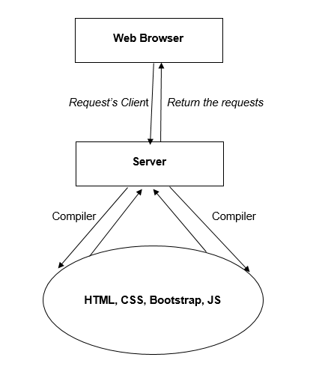

Diagram of the website

Tours

Home Page

About Us

Contact

**End**

|  |  |  |  |  |  |  |  |  |  |  |
| --- | --- | --- | --- | --- | --- | --- | --- | --- | --- | --- |
|  |  |  | TASK SHEET REVIEW 1 | | | | |  |  |  |
|  |  |  |  |  |  |  |  |  |  |  |
|  |  |  | **Project Ref. No.:** |  |  |  |  |  |  |  |
|  |  |  | **eP/Advertisement** |  | **Activity** | **Date of Preparation of Activity Plan:** | | | |  |
|  |  | **Portal Management** | | **Project** | **Plan** |  |  |  |  |  |
|  |  |  | **System/01** | **Title:** | **Prepared** |  |  |  |  |  |
|  | **Sr.** |  |  |  | **By:** | **Actual** | **Actual** | **Team** |  |  |
|  |  | **Task** |  |  | **Start** | **Mate** | **Status** |  |
|  | **No.** |  |  |  | **Days** |  |
|  |  |  |  |  | **Date** | **Names** |  |  |
|  |  |  |  |  |  |  |  |  |
|  | 1 |  | Acknowledgment |  |  | 15/06/20 | 1 | Hoang |  |  |
|  | 2 |  | Synopsis |  |  | 16/06/20 | 1 | Hoang |  |  |
|  | 3 |  | Problem Statement |  |  | 15/06/20 | 1 | Huy | Completed |  |
|  | 4 |  | Analysis of the |  |  | 17/06/20 | 1 | Huy | Completed |  |
|  |  |  | requirements about the |  |  |  |  |  |  |  |
|  |  |  | website |  |  |  |  |  |  |  |
|  | 5 |  | The scope of the work | Pleasant Tours | Hoang | 18/06/20 | 1 | Huy | Completed |  |
|  |  |  | (in brief) |  |  |  |  |  |
|  |  |  |  |  |  |  |  |  |  |
|  | 6 |  | Architecture and design |  |  | 17/06/20 | 1 | Thinh | Completed |  |
|  |  |  | of the system |  |  |  |  |  |  |  |
|  | 7 |  | Diagram of the website |  |  | 18/06/20 | 1 | Thinh | Completed |  |
|  | 8 |  | Task Sheet |  |  | 15/06/20 | 1 | Hoang | Completed |  |
|  |  | | |  |  |  |  |  |  |  |
|  | **Date:** | | |  |  |  |  |  |  |  |
|  |  | | |  |  | | | |  |  |
|  | Signature of Instructor: | | |  | Signature of Team Leader: | | | |  |  |



|  |  |
| --- | --- |
| **Ms. Le Mong Thuy** | **Mr. Nguyen Quoc Hoang** |



Site map

Home Page

Home

Tours

Options 1, 2, 3,…

Contact

Options 1.1 ,1.2,… …

About Us Page

About Us

Address & Map, Contact Form

Mock of the website

1. Home Page

**HEADER (LOGO)**

**HEADER (NAV BAR)**

**PICTURE TOUR**

**(SLIDE SHOW)**

**Popular Destination**

**Video + Reviews**

1. 2. Tours

**FOOTER**

**HEADER (LOGO)**

**FOOTER**

**HEADER (NAV BAR)**

**PICTURE TOUR**

**ALL TOURS**

**With Filter**

1. About us



**HEADER (LOGO)**

**INFOMATION COMPANY**

**FOOTER**

**REVIEWS**

1. Contact

**HEADER (LOGO)**

**HEADER (NAV BAR)**

**FOOTER**

**CONTACT FORM**

**MAP**

TASK SHEET REVIEW 2

|  |  |  |  |  |  |  |  |  |
| --- | --- | --- | --- | --- | --- | --- | --- | --- |
|  |  | **Project Ref. No.:** |  |  |  |  |  |  |
|  |  | **eP/Advertisement** |  | **Activity** | **Date of Preparation of Activity Plan:** | | | |
|  | **Portal Management** | | **Project** | **Plan** |  |  |  |  |
|  |  | **System/01** | **Title:** | **Prepared** |  |  |  |  |
| **Sr.** |  |  |  | **By:** | **Actual** | **Actual** | **Team** |  |
|  | **Task** |  |  | **Start** | **Mate** | **Status** |
| **No.** |  |  |  | **Days** |
|  |  |  |  | **Date** | **Names** |  |
|  |  |  |  |  |  |  |
| 1 |  | Site map |  |  | 18/06/20 | 1 | Thinh | Completed |
| 2 |  | Mock of the website | Pleasant Tours | Hoang | 19/06/20 | 1 | Thinh | Completed |
| 3 |  | Task sheet |  |  | 17/06/20 | 1 | Hoang | Completed |



**Date:**

|  |  |
| --- | --- |
| Signature of Instructor: | Signature of Team Leader: |
| **Ms. Le Mong Thuy** | **Mr. Nguyen Quoc Hoang** |
|  |  |

WEBSITE DESCRIPTION

1. Home page
   1. *Description*

This webpage displays following information: Pleasant Tours introduction, all tours provided with initiary and price, reviews from customers and contact infomation.

* 1. *Screenshot*

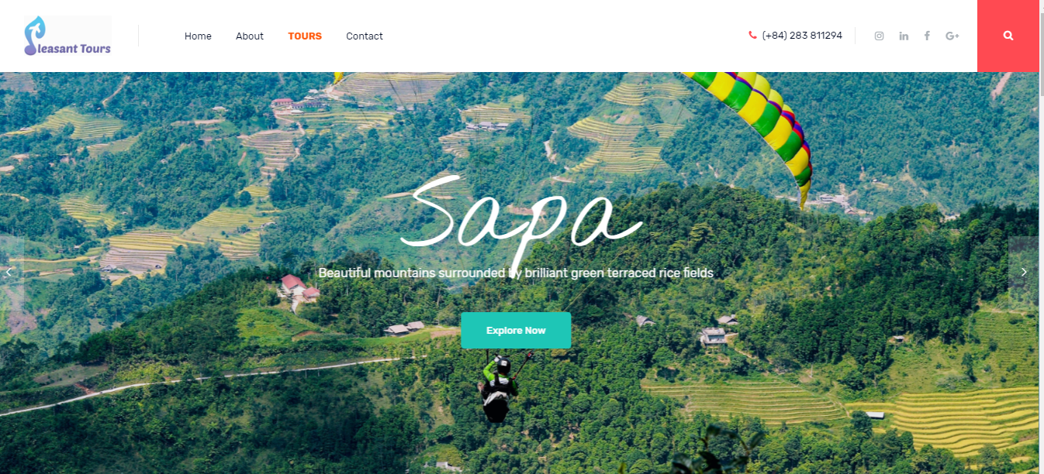

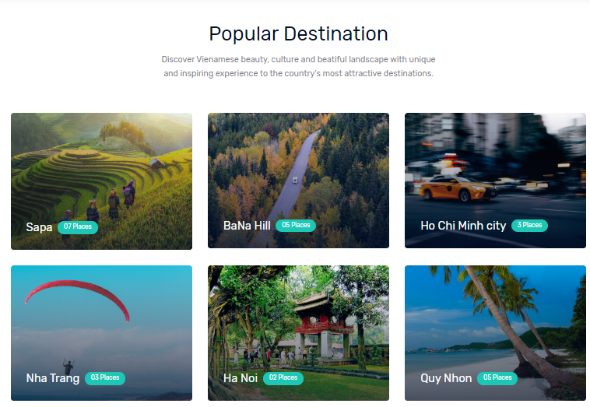

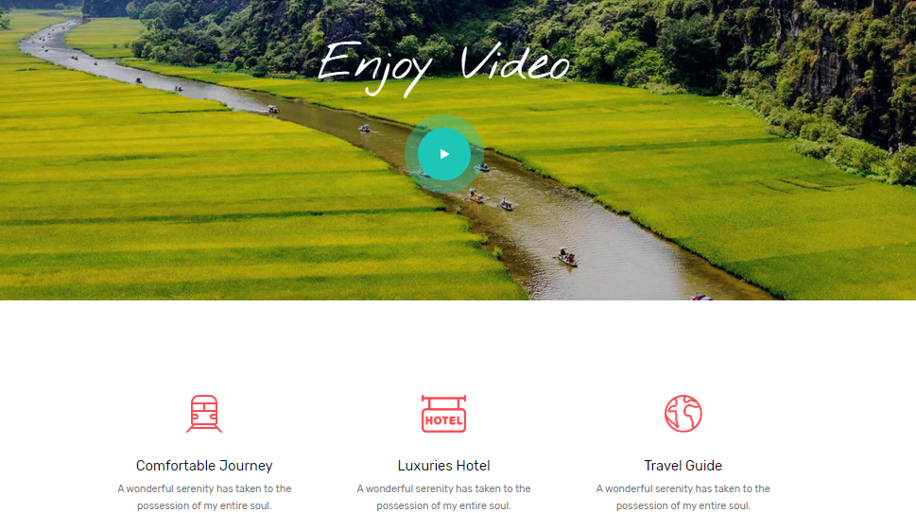\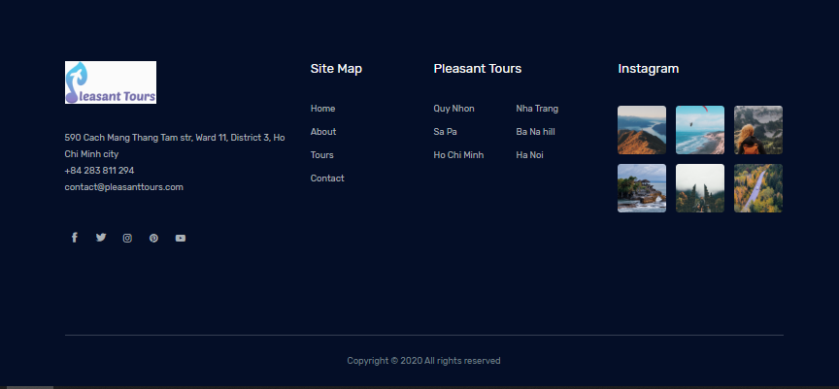

* **Navigation bar**

*Description*

This menu bar allows users to navigate to every webpage of the whole website. For example, users need to click on Tours so the Tours page will open. The same method is applied for other pages.

1. Tours
2. *Description*

This webpage displays tours categorized by tour type as moutains, beaches or cities tours. Users can filter the tours in type category, Tours will be presented with key information about location, time, price. User can view or download for tour initiary and all price.

1. *Screenshot*

|  |  |
| --- | --- |
|  |  |

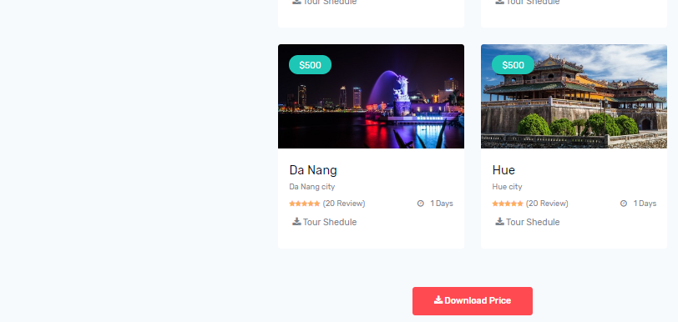

* + **Example of a detailed tour page**
* *Description*

This webpage displays detailed information of tours such as: Location, tour schedule and activities, videos, images and price clarification

* *Screenshot*
* 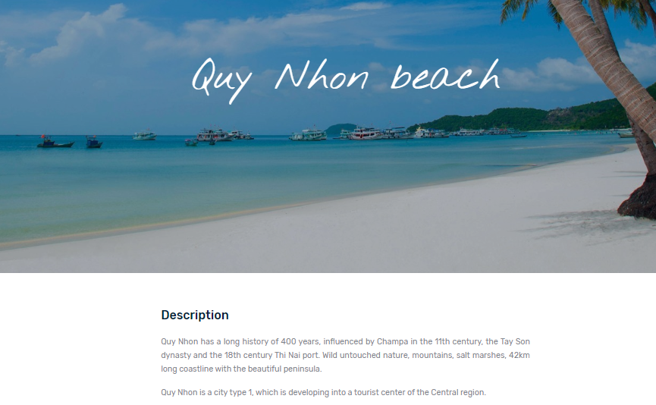
* 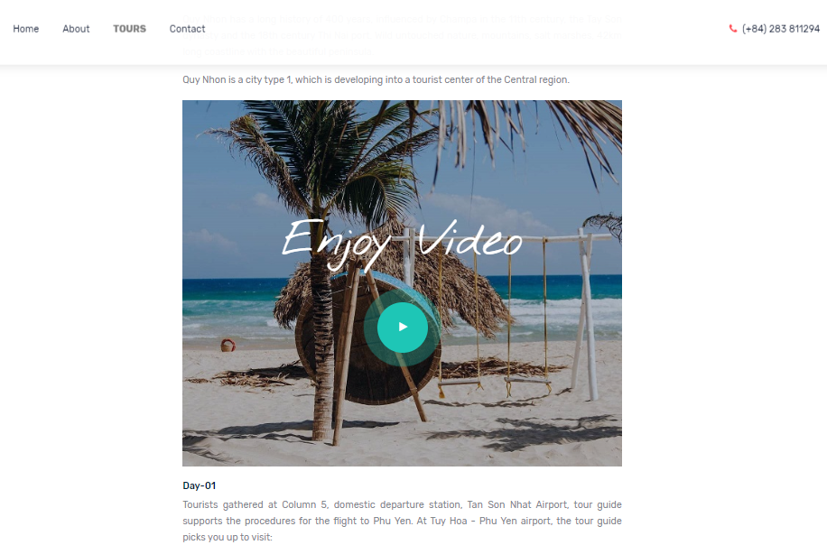



1. About us
2. *Description*

This webpage displays short introduction of the company and the tours. It also gives the number of tours has done and customers who had good reviews to the tours.

1. *Screenshot*

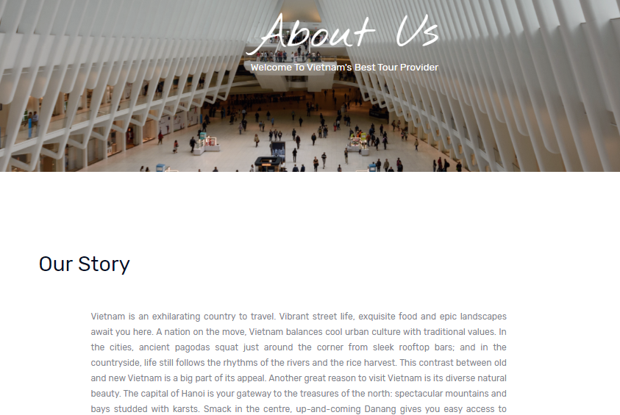

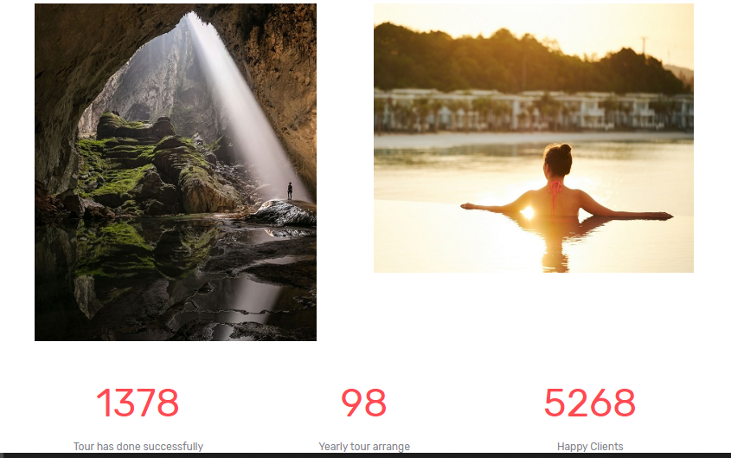

1. Contact Us
2. *Description*

This webpage allows users to request information they inquire to Pleasant Tours and displays the geolocation of the company.

1. *Screenshot*

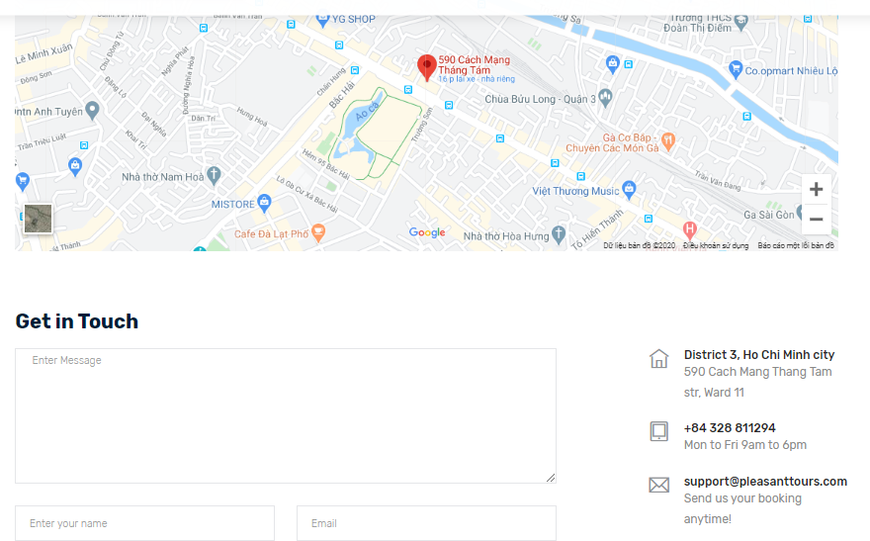

JAVASCRIPT DESCRIPTION

This chapter will provide information about JavaScript function integrated in the website **1. Slideshow function**

1. *Description*

This script is used for filter the tours in category for the Tours page.

1. *Screenshot*

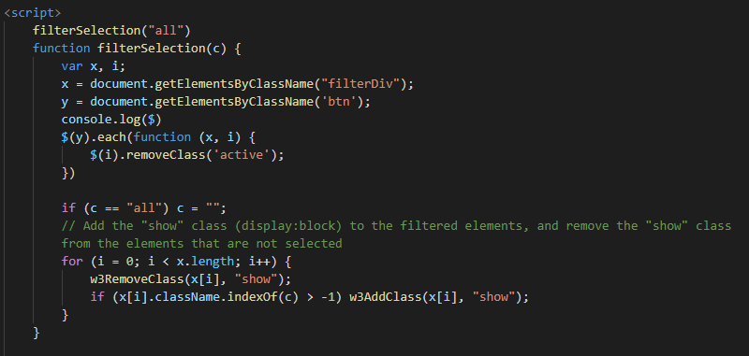

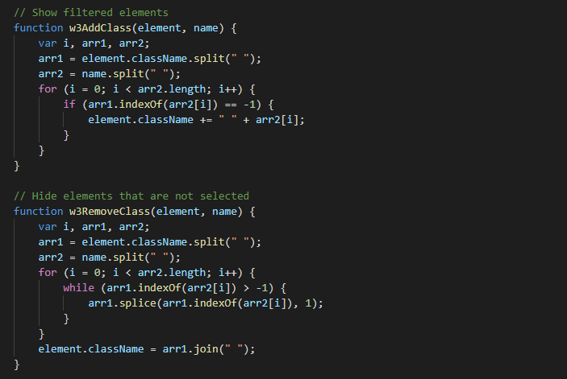

**2. Confirm for user subcription**

1. *Description*

This script is used for creating confirmation after user subscribe their email to the website.

1. *Screenshot*

** 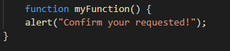



|  |  |  |  |  |  |  |  |  |  |  |  |
| --- | --- | --- | --- | --- | --- | --- | --- | --- | --- | --- | --- |
|  |  |  |  |  |  |  |  |  |  | |  |
|  |  |  |  |  |  |  |  |  |  |  |  |
|  |  |  |  |  |  |  |  |  |  |  |  |
|  |  |  |  | TASK SHEET REVIEW 3 | | | | |  |  |  |
|  |  |  |  |  |  |  |  |  |  |  |  |
|  |  |  | **Project Ref. No.:** |  |  |  |  |  |  |  |  |
|  |  |  | **eP/Advertisement** |  |  | **Activity** | **Date of Preparation of Activity Plan:** | | | |  |
|  |  | **Portal Management** | |  | **Project** | **Plan** |  |  |  |  |  |
|  |  |  | **System/01** |  | **Title:** | **Prepared** |  |  |  |  |  |
|  | **Sr.** |  |  |  |  | **By:** | **Actual** | **Actual** | **Team** |  |  |
|  |  | **Task** |  |  |  | **Start** | **Mate** | **Status** |  |
|  | **No.** |  |  |  |  | **Days** |  |
|  |  |  |  |  |  | **Date** | **Names** |  |  |
|  |  |  |  |  |  |  |  |  |  |
|  | 1 |  | Home page |  |  |  | 17/07/20 | 1 | Hoang | Completed |  |
|  | 2 |  | Tours |  |  |  | 17/07/20 | 3 | Thinh | Completed |  |
|  | 3 |  | About |  |  |  | 17/07/20 | 1 | Hoang | Completed |  |
|  | 4 |  | Contact us |  | Pleasant Tours | Hoang | 17/07/20 | 1 | Hoang | Completed |  |
|  |  |  |  |  |  |  |  |  |  |  |  |



**Date:**

|  |  |
| --- | --- |
| Signature of Instructor: | Signature of Team Leader: |
| **Ms. Le Mong Thuy** | **Nguyen Quoc Hoang** |
|  |  |

